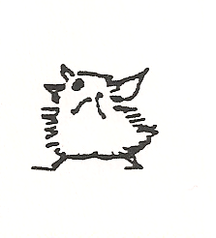

1
Susie the Pink Chicken

Fill the missing Words

It is a Nonday morning, and Susie the pink _ _ _ _ _ _ is woken up by her _ _ _ _ _ _, Bruce the big black _ _ _ _ _ _.

_ _ _ _ _crows out at the break of dawn every day.
He os ;ole am _ _ _ _ _ clock to Susie. It tells her to _ _ _ up and get _ _ _ _ _ for school.

But first, like all good _ _ _ _ _ _ chickens, Susie must have her _ _ _ _ _ _ _ _ _.

As Susie is getting ready for school her Mother is getting her _ _ _ _ _ ready.

Then Susie’s Mother _ _ _ _ _ her a kiss and tells her to be a _ _ _ _ chicken at school.

chicken | mother | ready | Bruce | good
get | rooster | gives | lunch | father
every | breakfast | little

2
Search a word
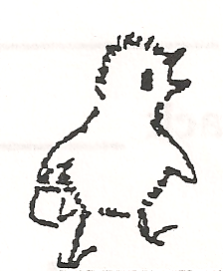

x | m | t | p | y | v | n | b | b | u | h | l | o
h | o | p | s | c | o | t | c | h | b | o | h | h
f | t | p | t | x | r | q | s | h | j | u | z | k
s | h | b | r | e | a | k | r | f | i | r | s | t
x | e | p | s | z | n | o | k | t | q | m | y | m
z | r | i | m | b | g | e | n | t | j | p | d | i
s | b | k | o | a | e | b | b | e | z | t | r | e
r | v | e | g | e | m | i | t | e | m | s | n | a
v | m | l | q | o | k | g | j | t | b | e | d | n
z | f | r | i | e | n | d | b | h | z | u | l | a

bed | friend
mother | vegemite
big | teeth
orange | first
hour | break
hopscotch

Crossword
2
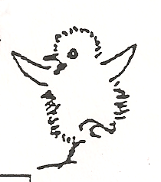
 | 1 |  |  | 2 |  |  |  | 3 |  |  | 4
5
 |  |  |  |  |  | 6
 |  |  |  | 7
8 |  |  | 9
 |  |  |  |  |  |  |  | 10
11 |  |  |  |  | 12
 |  |  |  |  |  |  |  | 13 |  |  | 14
15 |  |  |  |  | 16

Across | Down
3. Susie’s Mother will t___ her in (4) | 1. Like ___ good little children (3)
5. _____ her teeth (5) | 2. Something to eat after school (5)
7. Susie is a _______ (7) | 3. What did little Johnny do wrong? (4)
8. Opposite of white (5) | 4. Johnny stood in the ______ (6)
10. Susie does her home____ (4) | 6. Susie likes this colour (4)
11. Where Susie goes on Monday (6) | 9. Ticks and tells the time (5)
13. A good night k___ (4) | 10. She is w_____ up by her father (5)
15. Pigs are made into ____ (4) | 12. L___ all good little chickens (4)
16. Susie sits on her Dad’s knee | 14. A knee is handy to ___on (3)
Crossword solution

 | a |  |  | s |  |  |  | t | u | c | k
c | l | e | a | n |  |  |  | a |  | o
 | l |  |  | a |  | p |  | l |  | r
 |  |  |  | c | h | i | c | k | e | n
b | l | a | c | k |  | n |  |  |  | e
 |  |  |  |  |  | k |  | w | o | r | k
s | c | h | o | o | l |  |  | o
 |  |  |  |  | i |  |  | k | i | s | s
p | o | r | k |  | k | n | e | e |  |  | i
 |  |  |  |  | e |  |  | n |  |  | t

