Life in Laos

Filling the missing letter to get the names of the fruit and vegetables
1

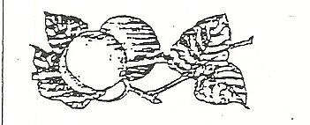  apr _ c _ t | 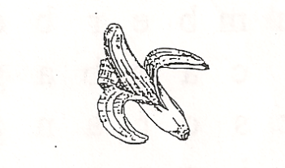  b _ n _ n _ | 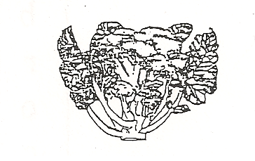  br _ _ _ oli
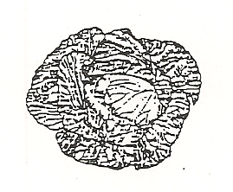  _ abba _ e | 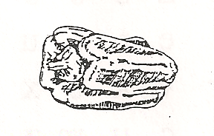  cap _ _ c _ m | 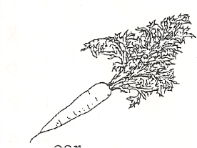  car _ _ _
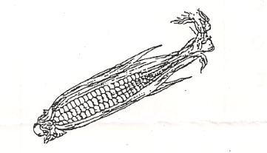  co _ n | 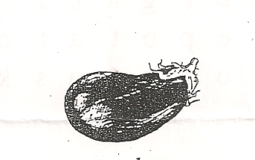  _ _ _ plant | 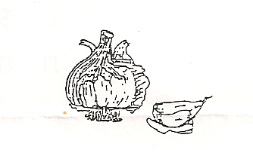  g _ _l _ c
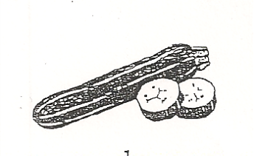  z _ cch _ _ _ | 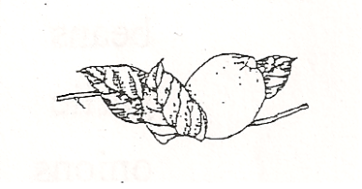  l _ m _ n | 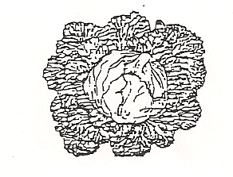  le _ _ tuce
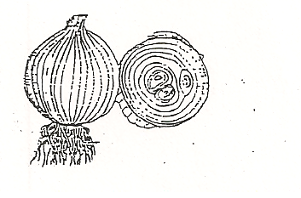  on _ on | 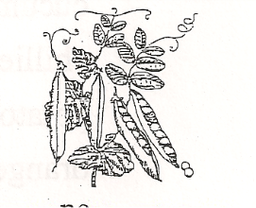  pe _ _ | 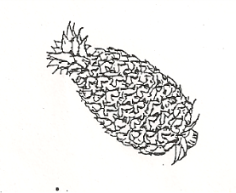  pine _ _ _ _ _
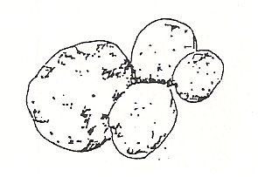  p _ t _ to | 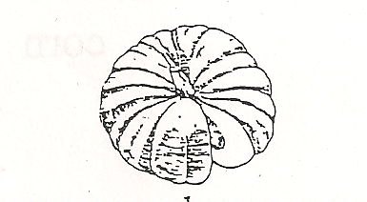  pu _ _ k _ n | 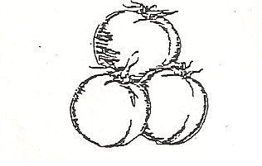  t _ _ _ t _
2
Search a word

b | c | u | c | u | m | n | e | r | n | e | x
r | d | o | v | i | c | a | b | b | a | g | e
o | e | x | k | z | s | o | r | a | n | g | e
c | h | i | l | l | i | e | s | x | a | z | e
c | r | d | e | g | g | p | l | a | n | t | i
o | k | p | m | r | z | s | s | s | a | r | a
l | b | u | o | l | e | t | t | u | c | e | p
i | e | m | n | r | v | k | o | x | x | s | r
c | a | p | s | i | c | u | m | z | d | x | i
o | n | k | e | c | r | g | a | r | l | i | c
r | s | i | i | e | p | o | t | a | t | o | o
n | o | n | i | o | n | s | o | o | s | k | t

capsicum | beans
pumpkin | garlic
lemons | onions
cabbage | cucumber
lettuce | chillies
broccoli | potato
eggplant | orange
banana | tomato
apricot | corn
rice

