A Wet Experience

Fill the gaps
1
There is a man who says, “I’ll put you in the pool.”
He often says it. He says it to everyone.
He says, “I’ll put you in the pool.”
It’s just like saying, “hello” or “g’day”.

One day this man was on a farm.
_ _ had a bike.
He rode the bike round and _ _ _ _ _.
He was having a great time.

There was a _ _ _ _ _ hill on the farm.
There was a dam _ _ the bottom of the hill.
The dam was _ _ _ _ of water.

He started to ride down the _ _ _ _.
Suddenly the brakes went!
His bike went _ _ _ _ _ _.
The man hung onto the handle bars.
Brr rr…

The man yelled, “Help! HELP!”
He tried to _ _ _ _ the bike.
He tried to slow it _ _ _ _.

The bike got faster and faster.
It _ _ _ _ _ _ and bounced down the hill, towards the dam _ _ _ _ .

He _ _ _ _ _ _. “Help! Stop! Oh! No! STOP!! Oooooo…”

The bike headed _ _ _ the dam wall.
It crashed into the wall. _ _ _ _ _ _ _!!
BANG!! C*R*A*S*H*!!

The man flew of the handle _ _ _ _ and S P L A S H!!! into the dam.

He dragged his bike out of the dam.
He was all wet.

The bike had a buckled wheel.
His clothes were wet. Hi boots were full of water. He was all wet and soggy. He had to walk the bike home.
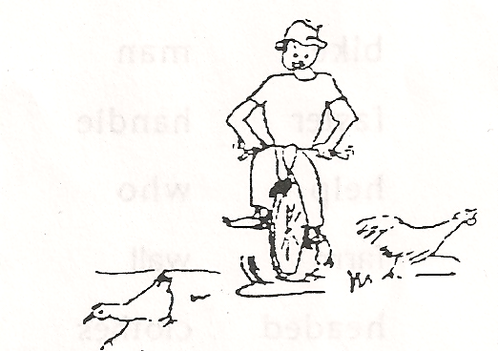
SQUISH
SQUASH
RATTLE
BANG
CLUNK!!

Words:
steep | wall | bars | down
faster | round | stop | full
SMASH | for | bumped
at | hill | he

Search a word
2
e | v | e | r | y | o | n | e | s | a | y | s | w | e | t
f | c | l | o | t | h | e | s | w | e | w | h | e | e | l
l | a | e | u | n | o | t | t | o | m | t | e | n | n | l
e | m | a | n | x | p | e | b | r | i | e | a | t | c | u
w | p | c | d | q | m | t | i | m | e | z | d | x | e | f
a | w | h | o | b | r | a | k | e | s | t | e | o | v | a
l | q | e | w | r | a | s | e | h | a | n | d | l | e | s
l | s | l | n | o | f | b | u | m | p | e | d | t | u | t
t | b | p | o | o | l | d | o | d | e | l | l | e | y | e
f | u | z | w | r | e | p | o | t | s | w | a | t | e | r

everyone | says | time
stop | yelled | bumped
bottom | wet | 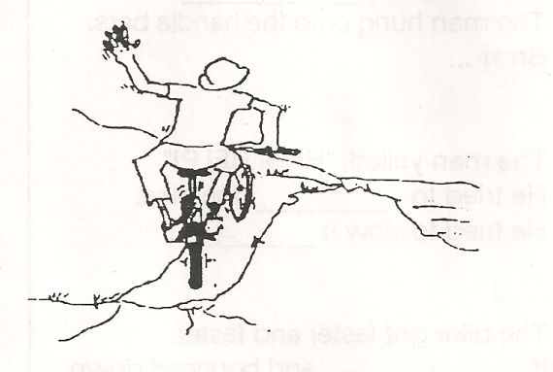  pool
bike | man | water
faster | handle | brakes
help | who | down
Farm | Wall | flew
headed | clothes | went
Full | round | wheel

*Use left-over letters to construct the title*

Crossword
3

1 |  |  |  |  |  | 2 |  |  |  |  |  |  |  | 3
 |  |  | 4 |  | 5
 |  |  |  |  |  |  |  | 6 |  |  | 7
 |  | 8
9 |  |  |  |  | 10 |  |  | 11
 |  |  |  |  |  |  | 12 |  |  |  |  | 13
14 |  |  | 15
 |  |  | 16 |  |  |  |  |  |  | 17

Across | Down
2. the opposite to slower | 1. opposite to in
4. what goes up must come _ _ _ _ | 3. something to hold onto
6. place to see animals | 5. this may be found in a dam
9. to halt | 7. male person
10. the bike _ _ _ _ _ _ _ _ and bounced down the hill | 8.not me
14. a snail’s pace | 9. He _ _ _ _. “I’ll put you in the pool”
16. the bike _ _ _ _ _ _ for the dam wall | 11. a circular shape
17. a watch will show this | 13. a place to hold water
 | 15. he can’t remember _ _ _ he did it

CROSSWORD SOLUTION

o |  |  |  |  |  | f | a | s | t | e | r |  |  | h
u |  |  | d | o | w | m |  |  |  |  |  |  |  | a
t |  |  |  |  | a |  |  | f | a | r | m |  |  | n
 |  |  |  |  | t |  |  |  |  |  |  |  |  | d
s | t | o | p |  | e | v | e | r | y | o | n | e |  | l
a |  |  |  |  | r |  |  | o |  |  |  |  |  | e
y |  |  |  |  |  |  | b | u | m | p | e | d
s | l | o | w |  |  |  |  | n |  |  |  | a
 |  |  | h | e | a | d | e | d |  | t | i | m | e
 |  |  | e

